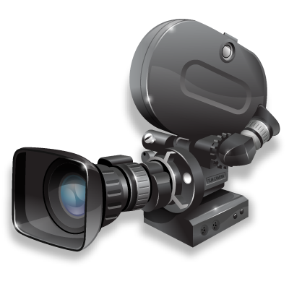 | Film Evaluation  Film: _ _ _ _ _ _ _ _ _ _ _ _ _ _ _ _ _ _ _  Date Reviewed: _ _ _ _ _ _ | Location/Media  Cinema _____________________  Home_______________________  Alone/ With Others  Your choice? Chosen for you?  If Home: DVD, DVR  Online service_________________

Would you recommend this movie to friends/ family? | Definitely not Probably not Probably Definitely

Item | Don’t know | Needs work | Satisfactory | Good | Excellent | Comments
Story/Plot/Script
Acting
Dialog
Directing
Camera work/Cinematography
Music
Sound
Set design/props/costumes
Overall opinion

General Comments:

Question | NO | Somewhat | YES | Comments
Did you care about the characters in the story?

Did the movie capture and keep your attention?

Did the movie make you laugh?

Would you buy a DVD of this movie?

Would you watch this movie if it was on TV?

What was the best thing about this movie?
What was the worst thing about this movie?

Circle the genre(s) that you feel best describes the movie.  Credit: http://www.imdb.com/genre | 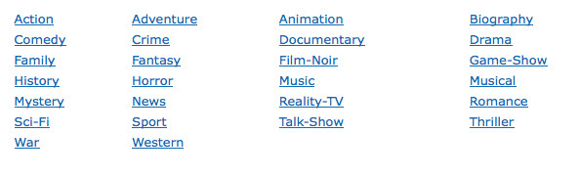

Write a 1-2 sentence blurb describing the film:

Observations re: Acting, Cinematography, Lighting, Sound, Effects:

